IOAI2025 GAITE: Combinatorial Word Segmentation

Note: Please "join" the competition first. Then, you can mount the dataset to the GPU. Otherwise, the notebook may encounter an error because it cannot access the dataset until you have joined the competition.

1. Problem Description
Compounds, which refer to the formation of new words from several short words, are particularly common in German. For example, 'Fußball' is a combination of 'Fuß' and 'Ball', which means 'foot' and 'ball'; 'Autobahnanschlussstelle' is a combination of 'Autobahn', 'Anschluss' and 'Stelle', which means 'highway', 'connection', and 'place'.
In this question, we need to split the combination of words in a German sentence into short words separated by spaces. For example, 'Fußballspieler' should be split into 'Fuß', 'ball' and 'spieler'.

2. Dataset
The training set (data/train.json) contains more than 90,000 German combining words, each of which has been segmented into short words. Each data contains two fields, the combining word and the segmentation label.
The validation set (val.json) and the testing set (test.json) contain more than 10,000 German combining words each. The specific data sizes are as follows:
- Training set: 94,306 entries, stored in train.json;
- Validation set: 11,788 entries, stored in val.json;
- Testing set: 11,789 entries, stored in test.json;
- Example data is as follows:
{
"Sprachbereich": [
0,
0,
0,
0,
0,
1,
0,
0,
0,
0,
0,
0,
1
],
"Autobahnanschlussstelle": [
0,
0,
0,
1,
0,
0,
0,
1,
0,
0,
0,
0,
0,
0,
0,
0,
0,
0,
0,
0,
0,
0,
1
],
...
}
The data is in json format, with key as the combination word and value as a 0-1 array, where each position of the array corresponds to the corresponding letter of the combination word, where 1 indicates the end of a word, and 0 indicates the beginning or middle of the word.
For example, the first data set indicates that 'Sprachbereich' is split into 'Sprach' and 'bereich', so the value is taken to be 1 in the 5th position of value (position numbering counts from 0) as well as in the last position, and 0 in the other positions.
The 0-1 arrays of value for the validation and test sets are empty.

3. Task
Please implement a combinatorial word splitter that fills in the value of the validation set and the test set.
Hint: Embedding plus Deep Learning models such as LSTM are recommended.

4. Submission
Contestants are required to submit model training and inference code named 'submission.ipynb', which must include the training process of the training model and the testing process of the prediction validation set and test set, not only the trained model.
The output of 'submission,ipynb' is a packaged zip, which contains two files, 'submissionval.json' and 'submissiontest.json', in the same format as the training set, with the content of the predictions for val.json and test.json.
The baseline.ipynb provides the submission format.

5. Score
The final score is the average F1-score of each combination word. val.json's scoring result can be queried in the Leaderboard A list during the competition; test.json's scoring result can not be queried during the competition, and it will be displayed at the end of the competition, which will be calculated to the final score before unification.
Hint: you do not need to look at F1-score in details, you can intuitively understand that the more accurate the predicted position, the higher the score.

6. Baseline an Training Set
- The baseline is in baseline.ipynb.
- The dataset is in training set.

7. Requirements
- Maximum submission limit: 50 times. Only successful submissions (i.e., those receive a score on Leaderboard A) will be counted toward the submission limit.
- Testing environment restrictions: The test machine will run your Notebook within 20 minutes. If the execution time exceeds 20 minutes, the system will forcibly terminate and return a feedback of “Timeout” or “Failed”.
- Data and model submission: In this task, participants can only submit a Notebook and cannot submit any mounted datasets or .pth files generated by themselves. Please check the upright corner to remove the mounted dataset first.
- 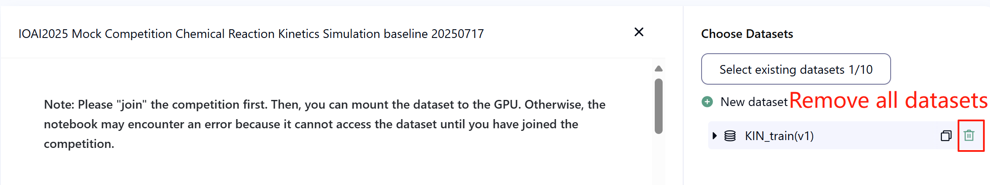

- Network: For the on-site stage, the test machine cannot connect to the internet. In other words, downloading commands such as 'pip' and 'conda' or trying to call APIs will not work.
- Pretrained Model: Any pre-trained model can be used in this task when it can be imported properly without network connection and downloading. This message means the Bohrium cannot guarantee to exclude all the pretrained model in the Python image when installing the packages, when you find some useful ones, you can use them.

8. Precautions
- Which score is effective: Contestants can select up to 2 submission results for scoring (√ - selected， □ - not selected). The score before unification for this task will be determined by the higher score on the Leaderboard B among the two selected submissions. Other cases of score calculation: please refer to Appendix Platform Mechanisms and Restrictions for Individual Contest & GAITE.
- 

- If a contestant submits only once right before the end of the competition, the platform will wait for the result to be completed and use it to calculate the score.
- How to deal with ambiguity: Once there is a conflict between the task description and the training set, the data in the training set will be respected first, and the dataset will not be changed during the competition.
- Contestants can only access Leaderboard A during the contest and cannot access Leaderboard B. The final score will be calculated only based on the score in Leaderboard B.
- The highest score by the Scientific Committee for this task is 0.95 in Leaderboard B, this score is used for score unification.
- The baseline score by the Scientific Committee for this task is 0 in Leaderboard B, this score is used for score unification.

9. Hints
You can use LSTM to solve this problem. Different versions of LSTM have different results.
The process is to change the part inside the class MyModel(nn.Module): to a LSTM.
The code of LSTM can be achieved by asking chatbot in Bohrium.

